Command-Line Interface Operations And Disk Scheduling Algorithms

An Assignment submitted in partial fulfillment of the requirements for the degree of
Bachelor of Science
in
Computer Science

CS 2301 - Operating Systems 1
Term 4 - 2025
University of The People

May 13, 2025

Command-Line Interface Operations And Disk Scheduling Algorithms
Command-line scripting
Command-line scripting offers a powerful way to automate tasks and workflows. By creating scripts that combine a series of commands, developers and administrators can streamline processes such as data backups, scheduled tasks, log analysis, and system monitoring. This automation reduces manual intervention, enhances efficiency, and boosts productivity.
Task 1: Creating daily backups
This script performs daily backups of a specified directory. It starts by defining the source directory to be backed up and the destination directory where the backup will be stored. It creates a backup file named with the current date, compresses the source directory into a tar.gz file, and saves it in the backup directory. The script also logs the backup creation with a timestamp.
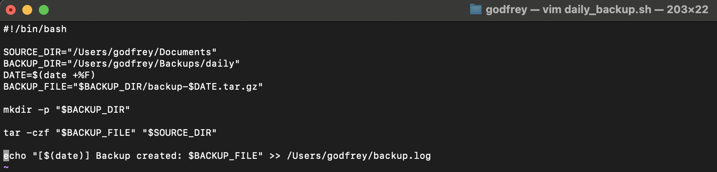
Task 2: Moving files
This script is designed to move log files older than one day to an archive directory. It begins by defining the directories for the logs and their archive. It creates the archive directory if it doesn't exist. The script searches for log files in the log directory that are older than one day, compresses them, and moves them to the archive directory. It logs the action with a timestamp.
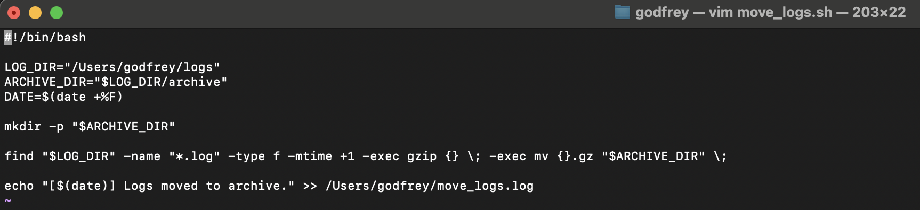
Task 3: Monitoring disk usage
This script monitors disk usage and triggers an alert if usage exceeds a specified threshold. It defines a usage threshold and an email address to receive alerts. The script checks the disk usage of mounted filesystems, and if usage exceeds the threshold, it logs an alert with a timestamp.
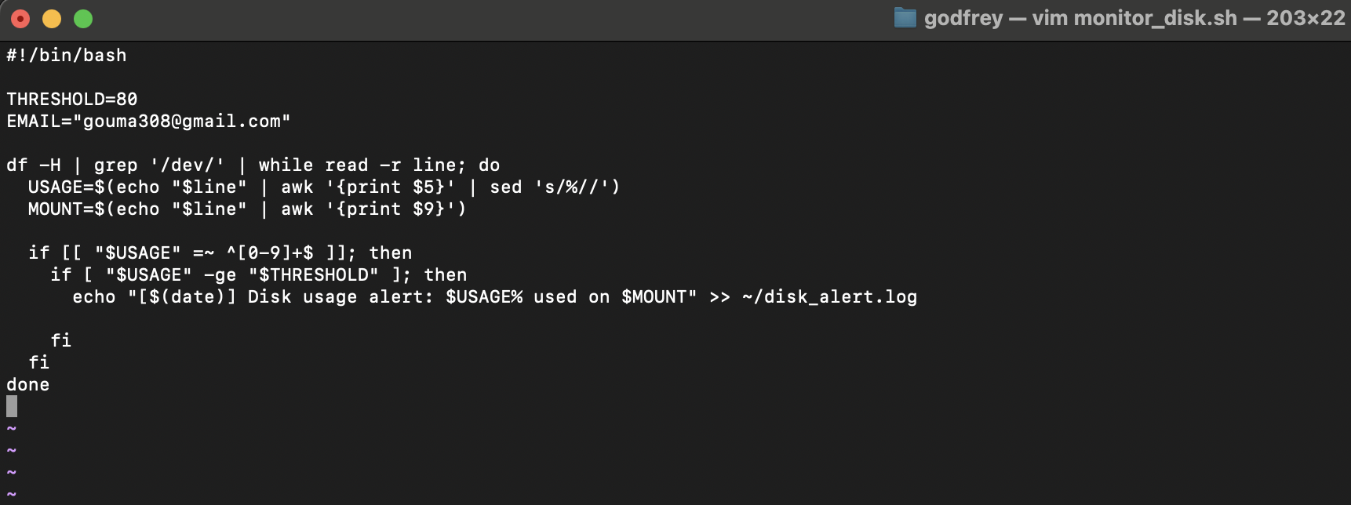
Automate with cron
Cron jobs are used to automate the execution of these scripts at specified times:
- daily_backup.sh: Runs at 2:00 AM every day.
- move_logs.sh: Runs at 1:00 AM every day.
- monitor_disk.sh: Runs every 30 minutes.
These cron jobs ensure the tasks are performed regularly without manual intervention.
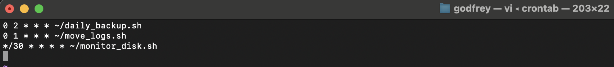
Automating routine tasks such as creating daily backups, moving log files, and monitoring disk usage can bring immense efficiency to a bank's IT department. However, writing Bash scripts to achieve these tasks presents several challenges.
- Creating daily backups: The script must ensure that the backup process is reliable and doesn't fail due to permission issues or disk space constraints. Additionally, maintaining an organized backup directory and log file is crucial for tracking and restoring data when needed.
- Moving log files: Handling large volumes of log files requires the script to be efficient in file traversal and manipulation. It must also account for file aging and compression to save space. Ensuring that the logs are accurately moved and archived without loss is critical.
- Monitoring disk usage: The script must be capable of parsing disk usage data accurately and triggering alerts when thresholds are exceeded. It must handle multiple server environments and provide timely notifications to prevent disk space issues.
These tasks require careful consideration of edge cases and system-specific conditions to ensure robust and reliable automation.
Disk Scheduling
The current First-Come, First-Served (FCFS) disk scheduling algorithm employed by the bank’s IT department is leading to significant delays in transaction processing times. This method processes disk requests in the order they arrive, without prioritizing efficiency. As a result, it often causes the disk head to move back and forth across the disk, leading to substantial seek times and increased latency (Silberschatz et al., 2013). Given the bank’s large volume of daily transactions, this inefficiency is particularly problematic, as it directly impacts the speed and reliability of transaction processing and ultimately, customer satisfaction. Inefficient disk access is a major bottleneck that affects the overall performance of the IT infrastructure, leading to longer wait times for customers and potential delays in critical operations.
To address these issues, I recommend implementing the Shortest Seek-Time First (SSTF) disk scheduling algorithm. SSTF prioritizes the disk requests that require the least movement of the disk head, thereby reducing seek times considerably. By always servicing the closest request next, SSTF minimizes the average seek time and enhances overall disk performance (Silberschatz et al., 2013). This improvement is especially beneficial for the bank, given the high frequency of disk accesses required for transaction processing. Compared to FCFS, SSTF offers a more efficient and reliable solution for managing disk I/O operations, ensuring faster transaction processing and improved system responsiveness (Silberschatz et al., 2013). Additionally, SSTF can significantly decrease the likelihood of disk thrashing, where excessive movement of the disk head can lead to inefficiencies and increased wear and tear on the hardware.
Alternative algorithms such as SCAN and C-SCAN also present viable options. SCAN, which moves the disk head in one direction until the end before reversing, and C-SCAN, which returns to the beginning without servicing requests on the return trip, both aim to reduce the variance in wait times. SCAN ensures that all requests are serviced systematically, preventing any single request from being ignored for too long. C-SCAN, on the other hand, provides a more uniform wait time for requests, as it treats the disk as a circular buffer and services requests in one direction only, resulting in a more predictable response time (Silberschatz et al., 2013). However, SSTF’s ability to consistently minimize seek times makes it the optimal choice for the bank’s environment. While SCAN and C-SCAN avoid starvation issues and provide uniform wait times, SSTF’s focus on minimizing seek time directly addresses the current bottleneck in transaction processing, providing the most significant improvement in disk performance. Implementing SSTF would streamline disk operations, reduce latency, and enhance the overall efficiency of the bank’s IT systems, leading to faster transaction processing and a better customer experience. Figure 1 shows a sample SSTF algorithm.
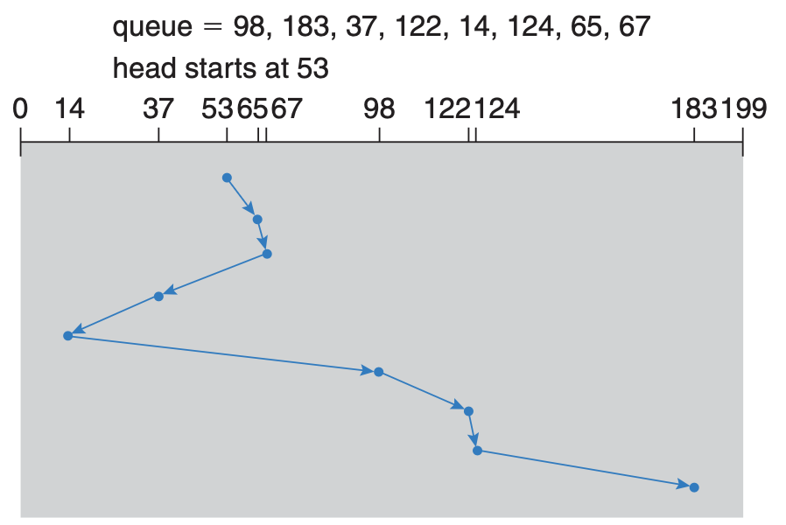
Figure 1 shows how the SSTF algorithm prioritizes disk requests that require the least movement of the disk head. Starting from the initial position, it services the closest request first, then proceeds to the next nearest one, minimizing seek times. For example, if the head is at cylinder 53, SSTF might service requests at cylinders 65, 67, 37, 14, 98, 122, 124, and finally 183, resulting in a total head movement of fewer cylinders compared to FCFS. Although efficient, SSTF can cause some requests to wait indefinitely if new, closer requests keep arriving.
References
Silberschatz, A., Galvin, P., & Gagne, G. (2013). Operating system concepts essentials (2nd ed.). John Wiley & Sons, Inc

